NPC Unit 3 Assignment
Configure a DNS Server and Web Server Using Cisco Packet Tracer

PRN: 2125UCSM1028
NAME: Laxmikant Gade
CLASS: SY Cyber Security

1. Objective
To configure a DNS Server and a Web Server in Cisco Packet Tracer and access a website using its domain name.

2. Requirements
- Cisco Packet Tracer
- Two PCs
- One Cisco 2960 switch
- One DNS Server
- One Web Server

3. IP Address Configuration
Device | IP Address | Subnet Mask
DNS Server | 192.168.10.2 | 255.255.255.0
Web Server | 192.168.10.3 | 255.255.255.0
Client PC 1 | 192.168.10.10 | 255.255.255.0
Client PC 2 | 192.168.10.11 | 255.255.255.0

4. Procedure
- Created a network topology containing two PCs, one switch, a DNS Server, and a Web Server.
- Connected all devices to the switch using Copper Straight-Through cables.
- Assigned static IP addresses to all devices.
- Enabled the HTTP service on the Web Server.
- Enabled the DNS service on the DNS Server.
- Added an A record mapping www.npc.local to 192.168.10.3.
- Configured both PCs to use 192.168.10.2 as their DNS Server.
- Used ping to test network connectivity.
- Opened the web browser on a PC and accessed http://www.npc.local.

5. Testing and Results
The ping tests verified connectivity between the PCs and the servers. The DNS service resolved www.npc.local to the Web Server's IP address. The website was successfully accessed through the PC's web browser using its domain name.

6. Conclusion
The DNS and Web Server were successfully configured in Cisco Packet Tracer. This experiment demonstrated how DNS translates domain names into IP addresses and how HTTP enables clients to access websites hosted on a Web Server.

7. Screenshots
- Screenshot 1: Network topology
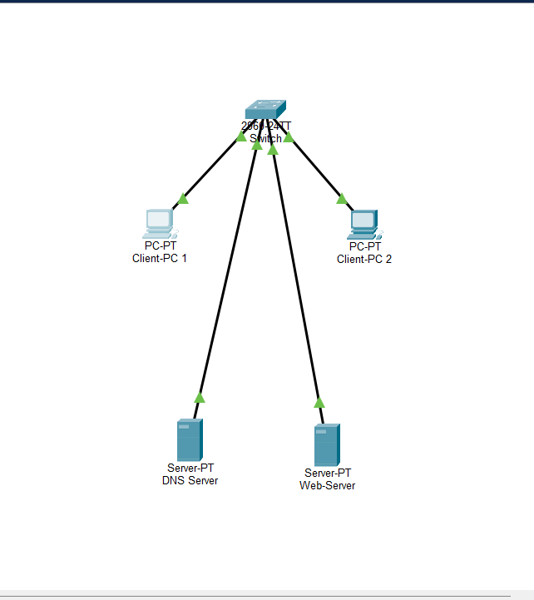

- Screenshot 2: IP configuration (client PC 2)
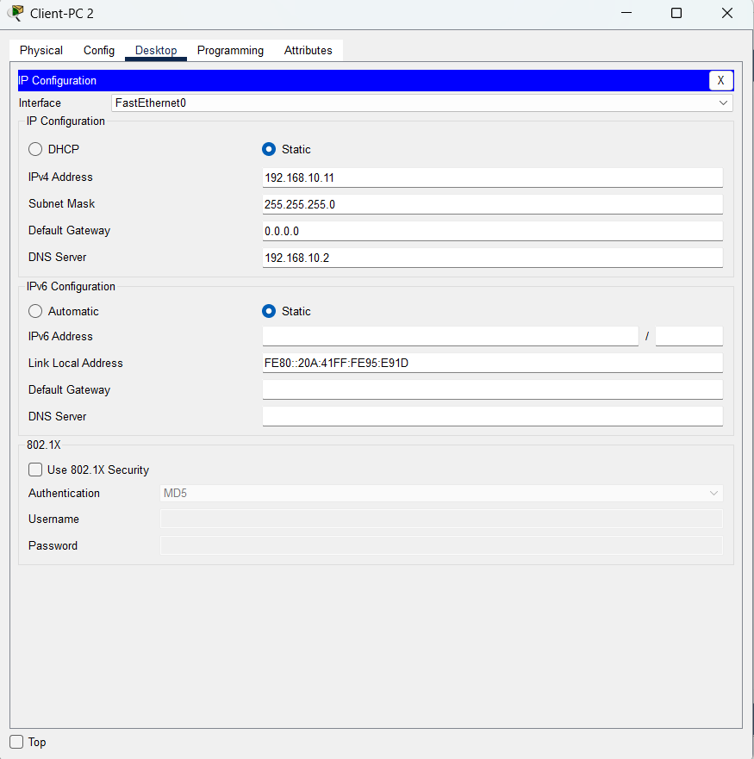

- Screenshot 3: DNS resource record
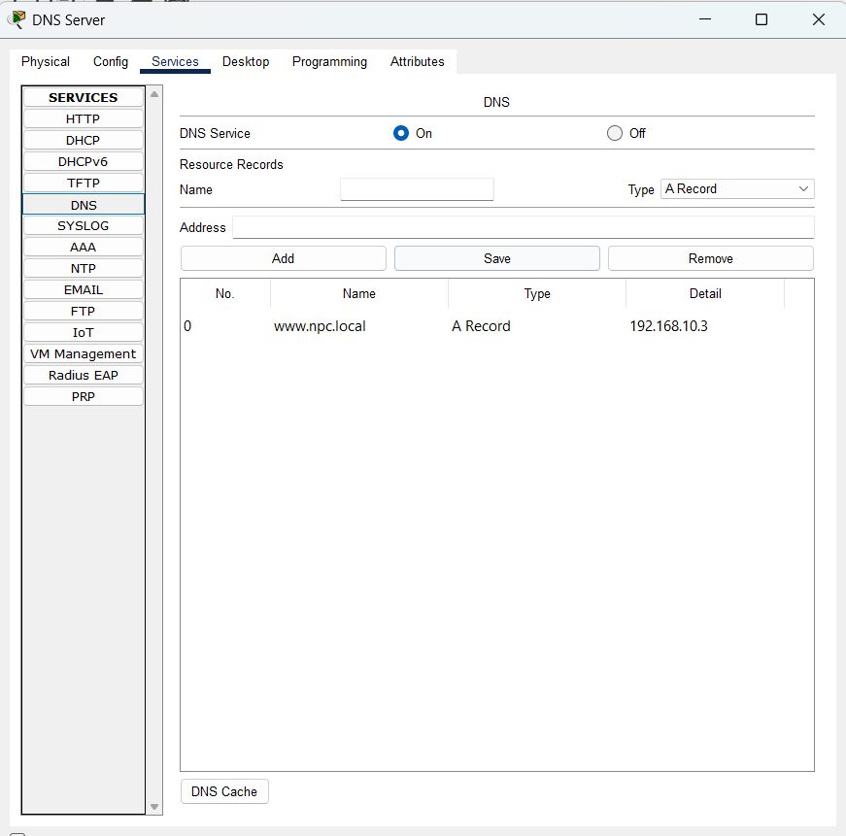

- Screenshot 4: Successful website access
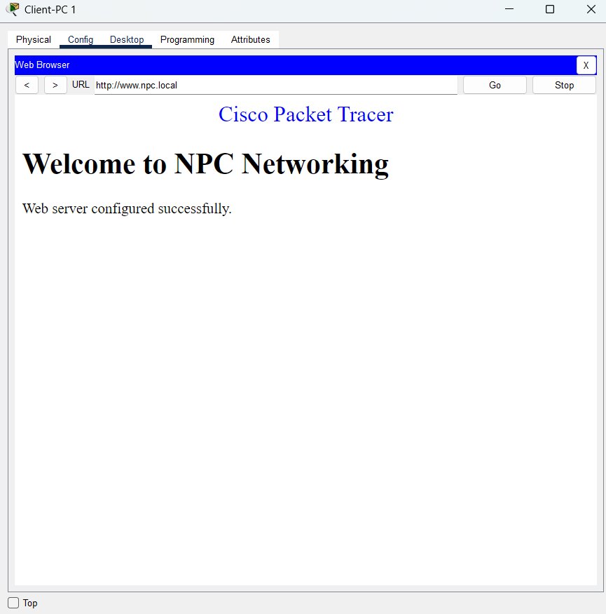

- Screenshot 5: Successful ping responses
